Remember
- To respect a child’s right to personal privacy.
- Never to make suggestive or demeaning remarks /gestures towards a child.
- Avoid physical horseplay with a child or any actions another adult may misinterpret no matter how innocent and well intentioned your actions may be.
- Do not converse with children via text messages or chat rooms.
- Never raise your hand or threaten a child.

If you have concerns about a child in the community you can contact the school head teacher, Social Worker, Police or health professional for advice and guidance.

Local contact details are available on www.forhighlandschildren.org or www.hcpc.scot

Working Together to Protect Children in the Highlands

“It’s everyone’s job to make sure I’m alright.”

Child Protection (Education)
Eliz MacIntosh
01641 521 297
07917596598

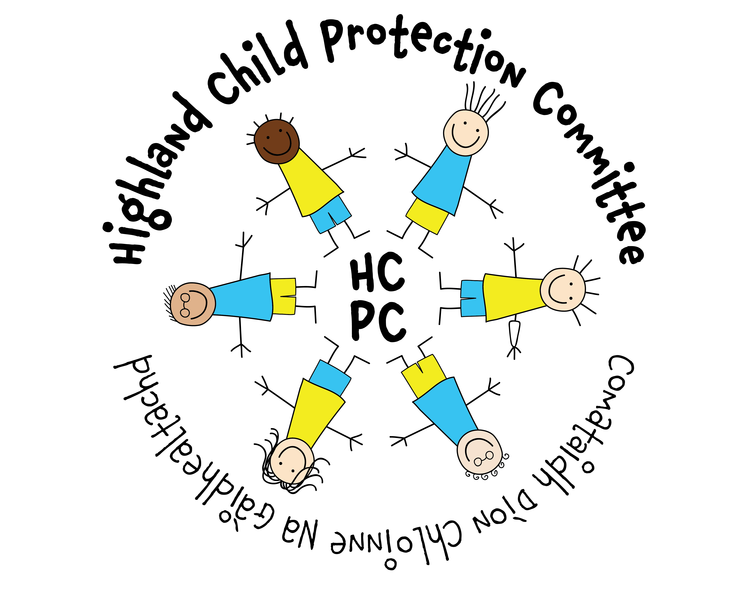

GETTING IT RIGHT IN
CHILD PROTECTION

Any adult who comes into contact with children on a regular basis needs to be
aware of Child Protection procedures.

The Designated Person for
Child Protection is

Mr Paul Milton

Head Teacher GUHS

Getting It Right For Every Child
All children should be:

S Safe
H Healthy
A Achieving
N Nurtured
A Active
R Respected & responsible
I Included

In Scotland we recognise the following types of abuse;

- Physical
- Sexual
- Emotional
- Neglect.

There are many things that may concern us about children/young people and these need to be shared with the school.

- Neglect e.g. children who appear hungry, or have inadequate clothing, poor hygiene, and whose medical needs are not being met.
- Physical abuse e.g. Children who have been injured by being hit, punched, burnt, scalded or given harmful substances.
- Sexual abuse e.g. Children who have been groomed or forced into sexual activity. This includes approaches through mobile phones and the internet.
- Emotional abuse e.g. Children who are constantly shouted at humiliated ,constantly criticised or threatened/ frightened

ALL Concerns about the well-being of a child/young person should be shared with the Designated Person immediately.

Remember to record in detail exactly what you see/hear with dates and time.

DO NOT INVESTIGATE
This is the role and responsibility of social work and/or the police.

CONFIDENTIALITY IS VITAL.
DO NOT discuss your concerns with anyone other than the designated person.

