Child Protection

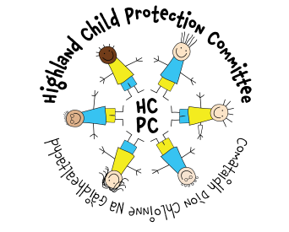

www.hcpc.scot

If you have a concern about a child/young person – speak to:

Mr Paul Milton (Head Teacher)

In their absence please contact

Mr Iain Fulton (Deput Head Teacher)

Eliz A MacIntosh
Child Protection (Education)
07917596598 or 01641 521 297
eliz.macintosh@highland.gov.uk

